**Andreu Mut Portes L1G1**

**Lesson 4**

* Comments on previous lesson.
* Today’s lesson activities.
* Do the activities on this document and upload it on POLIFORMAT – TAREAS.
* Deadline: During today’s class time

**Practice 4 - Medicine**

**PART 1**

**Page 151** New Language - Leader Meet the expert

**Activity 2b (write the number)**

1. **_3 Biocompatibility**
2. _~~4 Microchip technology~~ 1 Information biology
3. _5 Tissue engineering
4. _~~1 Information biology~~ 4 Microchip technology
5. _2Bionics

**Activity 3**

1. **_True. Bionics can mimic the functionality of a limb and carry with your life after an accident.**
2. **_False. They are too expensive**
3. **_False. He said the opposite, it is getting smaller.**
4. **_ False. She thinks that technology is only to help patients instead of improving human skills**
5. **_True. They are working close to mechanical engineers and with the devices they make.**

**PART 2**

Discuss giving reasons for your opinions (4/5 lines maximum):

* Do you agree with Tina, that microchip technology should only be used with patients, not healthy people?

I’m agree with Tina. I think people and microchip technology should be separated. They can be used in healthy way but not for improving human capabilities. Using that technology in human I believe that make us dumber because we will start trusting in that chip so it make our tasks by us. I also think that we will lose memory skills if we trust in that microchip to remember for us.

**Speaking Topic 4**

**PART 3**

**Discuss these ideas in the chat rooms.**

**Interaction (10 minutes maximum):**

1. **Discuss the implications of using microchips in humans:**

[**https://www.youtube.com/watch?v=0Ixr4SzoVJA&ab_channel=CBSThisMorning**](https://www.youtube.com/watch?v=0Ixr4SzoVJA&ab_channel=CBSThisMorning)

**2 members in the group agree with using microchips in humans and 2 disagree.**

Discuss these topics:

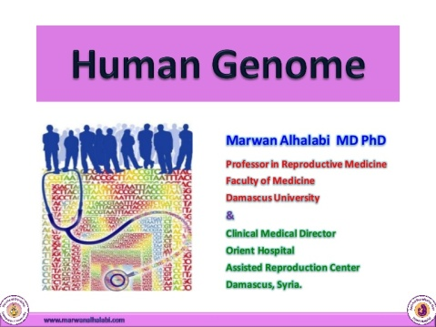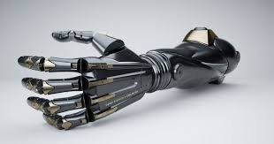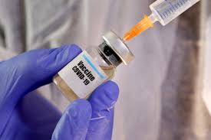**1. Why is research on these areas needed? Which is the most important area?**

In a pandemic, should vaccines be developed in public, government-funded research institutes or private pharmaceutical companies?

**2. Should we start introducing robot doctors?**

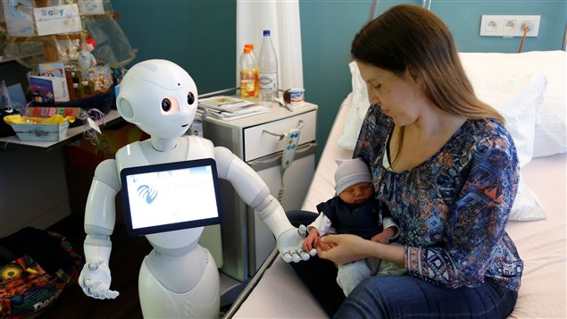

Would you like to have a robot doctor? Why / Why not?

**3. Should homeopathic medicine be legal?**

 

Should new drugs be tested on both animals and humans before being prescribed by doctors?

**4. Is mental health as important as physical health?**

 

Do you think going to the therapist should be free for everyone? Give reasons.